 | MINISTRY OF EDUCATION AND TRAINING

FPT UNIVERSITY

CAPSTONE PROJECT DOCUMENT
pLED
Report #3 – Software Requirement Specification
FAST5
Group Member | Nguyễn Thanh Tùng – SE01960
Group Member | Đinh Quang Hải – SE02354
Group Member | Đỗ Văn Ban - 01870
Group Member | Đinh Xuân Bách - 60343
Group Member | Nguyễn Thế Long – SE02241
Supervisor | Mr. Phan Duy Hùng
Ext. Supervisor
Project Code | pLED

- Hanoi, 02/2014 -
Table of Contents
1 USER REQUIREMENTS SPECIFICATION 4
1.1 Introduction 4
1.1.1 Purposes 4
1.1.2 Definition and Acronyms 4
1.2 Overall Description 4
1.2.1 Business Process Overview 4
1.2.2 Product Features 4
1.2.3 User Characteristic 4
1.3 Functional Requirements 5
1.4 Non – Functional Requirements 5
2 SYSTEM REQUIREMENTS SPECIFICATION 5
2.1 Introduction 5
2.1.1 Purposes 5
2.1.2 Definition and Acronyms 5
2.2 System Purpose 6
2.3 Scope 6
2.4 Overall Description 6
2.4.1 System overview 6
2.4.2 Product Features 6
2.4.3 User Characteristics 6
2.4.4 User Documentation 6
2.4.5 Assumption 7
2.5 Functional Specification 7
2.5.1 UC001: Turn On/Off System 8
2.5.2 UC002: Remote System 9
2.5.3 UC003: Setup Time 10
2.6 Non-functional Specification 11
2.6.1 Reliability 11
2.6.2 Performance Requirements 11
2.6.3 User Interface 12
2.6.4 Design Constraints 12
2.6.5 Usability 12
2.6.6 Security Requirements 12
2.6.7 Hardware/Software Requirements 12

USER REQUIREMENTS SPECIFICATION

Introduction

Purposes
The purpose of this document is to specify functional, nonfunctional requirements that the product must satisfy and some use cases that user can follow to use the product easier.

Definition and Acronyms
Term | Description
LED | Light emitting diode
RF | Radio Frequency module
DC | Direct current
Table 3-1: Definition and Acronyms

Overall Description

Business Process Overview
The pLED system main purpose is for entertainment and to demonstrate the ability of the PIC microcontroller in its various features. Also to prove the skills of development team in rebuild a device base on a common known physical phenomenon.

Product Features
The pLED is a mechanic and electronic system with the main feature is a series of LEDs that rotate around a focal point. With enough rotational speed, it will display a desire image on a circle plane. The mechanism is simplification of a TV screen.

User Characteristic
User of the system is any individual who wish to decorate their home or anyone who interest in physic, electronic device. The pLED can be used for demonstrate only or can be sold as a family commodity.

- Normal user: can understand the main features of the product and can use it in no more than 15 minutes.

- Advanced user: have technical knowledge about the product, configure it through computer software, and change its parameters.

Functional Requirements
- Display real time clock or image on rotating board with series of LEDs. The control task is responsibility of a PIC controller. The board is rotated by a DC motor.
- User can interact with the system through a RF module.
- System can be configured through computer software.

Non – Functional Requirements
- The display quality of clock or image on the rotation board.
- The stability of the system, power supply, running time.
- Response time of the system, after power on, response of user input.

SYSTEM REQUIREMENTS SPECIFICATION

Introduction

Purposes
- The software requirement specification assures the project management stakeholders and client that the development team has really understood the business requirements documentation properly. This also provides confidence that the team will develop the functionality which has been detailed.
- This is a documented in such a way that it breaks the deliverables into smaller components. The information is organized in such a way that the developers will not only understand the boundaries within which they need to work, but also what functionality needs to be developed and in what order.

Definition and Acronyms
This section describes the definitions, terms, and acronyms that are used in software requirements specification.
Items | Description
DC | Direct Current
AC | Alternating Current
PC | Personal Computer
RF | Radio Frequency
Table 3-1: Definition and Acronyms

System Purpose
- Propeller clock system is use to display real time and image or text.

Scope
- A functional Propeller clock system, display accurate real time and date right after plugged in a power source.
- A propeller display with battery to show an exact time/date whenever turned on.
- A set of display mode: Analog clock, digital clock, text/image, that can be change through a dedicated remote control.
- The dedicated remote using radio wave to control.

Overall Description

System overview
- Propeller clock system rotate then display image, text within selection from user remote by radio control.
- Propeller clock system will display real time when system off

Product Features
- Display clock in real-time.
- Two to three display option:
+ Digital clock
+ Analog clock
+ Static image or text
- User can change display mode by remote control.
- Multiple color display

User Characteristics
- N/A

User Documentation
- User manual: Device description
- User manual: radio remote controller mapping

Assumption
- Software process model is spiral

Functional Specification
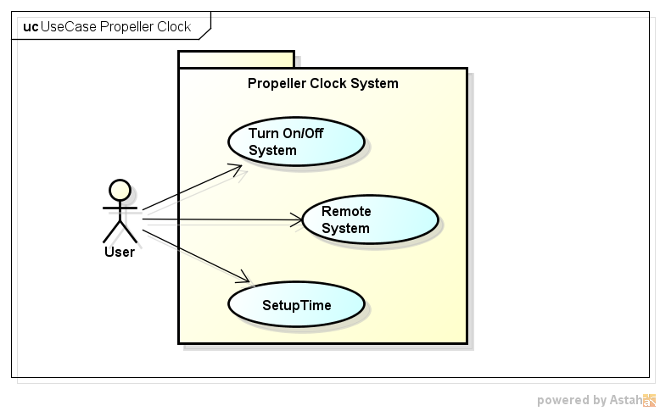
- Turn ON/OFF system:
- When user press button ON, the power supply to system is 12V DC, Proper Clock rotate, then an image will display.
- When user press button OFF, Propeller clock system rotating to stop, the power supply to system is 0V DC, system is terminate.
- Remote System:
- When user press button on RF remote control, Propeller clock system will display an image within selection.
- Setup Time
- When user connect Propeller clock system with PC via RS232, then user use an application setup time.

UC001: Turn On/Off System

Use Case Diagram
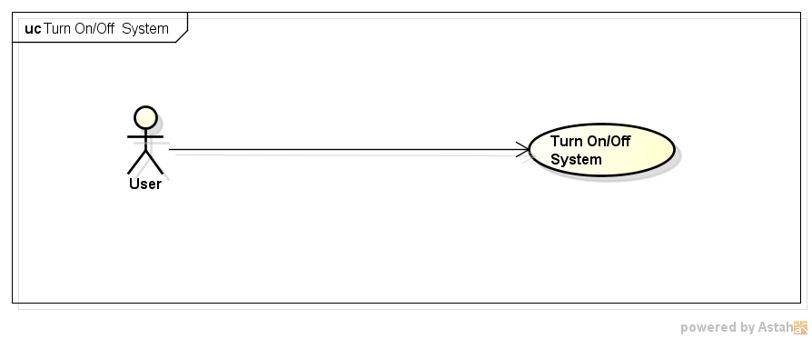

Use Case Specification

Use Case ID : |  | UC001
Use Case Name : |  | Turn On/Off System
Description : |  | User press button ON then Propeller clock system is beginning rotate.
Primary Actor: |  | User
Pre-Condition: |  | Power input 220V AC
Post-Condition: |  | Power system output 12V DC
Flow of Events |  |  |  |  |  | Actor Input |  | System Respond
 |  |  |  | 1 |  | Press button ON
 |  |  |  | 2 |  |  |  | Propeller clock system rotate
Use Case ID : | UC001
Use Case Name : | Turn On/Off System
Description : | User press button OFF then Propeller clock system is terminate.
Primary Actor: | User
Pre-Condition: | Power input 220V AC  Power system 12V DC
Post-Condition: | Power system 0V DC
Flow of Events |  |  |  |  | Actor Input |  | System Respond
Flow of Events |  |  | 1 |  | Press button OFF
Flow of Events |  |  | 2 |  |  |  | Propeller clock system is rotating to stop

UC002: Remote System

Use Case Diagram
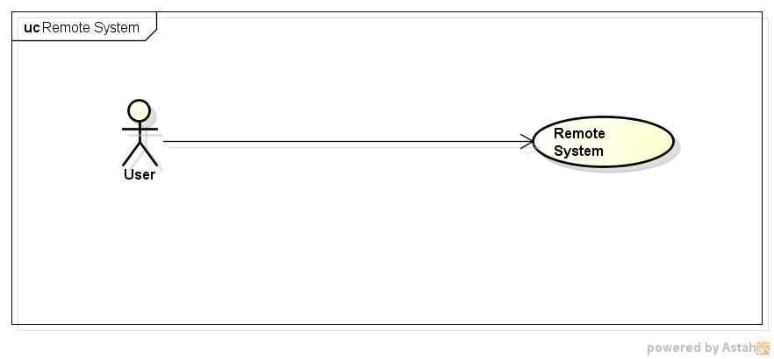

Use Case Specification
Use Case ID : | UC002
Use Case Name : | Remote System
Description : | User press button on RF remote then Propeller clock system will display image
Primary Actor: | User
Pre-Condition: | Power system 12V DC
Post-Condition: | Power system output 12V DC  Proper Clock rotate
Flow of Events |  |  | Actor Input | System Respond
Flow of Events |  | 1 | Press button on RF remote control
Flow of Events |  | 2 |  | Propeller clock system display image within selection

UC003: Setup Time

Use Case Diagram
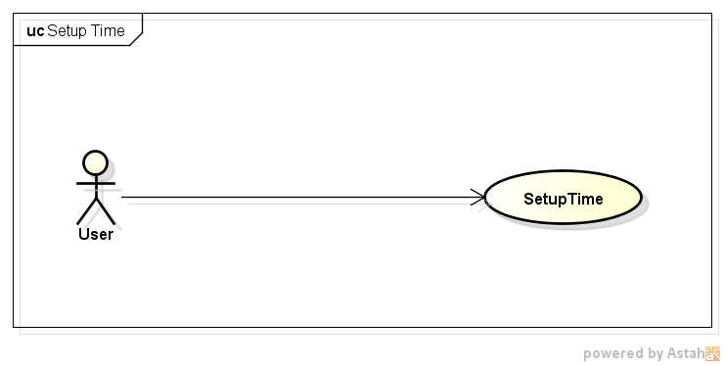

Use Case Specification
Use Case ID : | UC003
Use Case Name : | Setup Time
Description : | Users connect Propeller clock system with PC via RS232, then setup time for clock by application.
Primary Actor: | User
Pre-Condition: | System is off
Post-Condition:
Flow of Events |  |  | Actor Input | System Respond
Flow of Events |  | 1 | User connect system with PC via RS232 by application
Flow of Events |  | 2 |  | System checking status is connected
Flow of Events |  | 3 | User setup time on application, then click button Apply
Flow of Events |  | 4 |  | System update new time

Non-functional Specification

Hardware
- Power supply is robust
- Motor rotate stable
- Real time display

Performance Requirements
- Speed of motor at least 20 cycle per second
- Picture display smoothly

Availability
- Run 12 hours
- Power supply run at 220V AC ( Voltage’s family )
- Run at temperature -10⁰C to 50⁰C

Response time
- When motor run, power up, system display within 3s
- When use remote control, system respond after 1s

User Interface
N/A

Design Constraints
- Speed of motor enough to display picture smoothly
- Design motor supply into board with enough power
- System vibration suitable

Usability
- User training after 5 minutes

Security Requirements
- Avoid electric shock - proof

Hardware/Software Requirements
- Design power supply 12V DC
- Design board easy to mechanical welding
- Design PC software to connect board via RS232
- Using RF component to remote system

